ST. PATRICK KIGULU GIRLS’ BOARDING PRIMARY SCHOOL
REVISION EXERCISE
P. 2 MATHEMATICS 2020
Name:…………………………………………………………… Stream:………..………..
SECTION A
- Add correctly: 12 + 10

- Write in words: 12

- Describe the set below;
A set of cows going to school.

- Add the fractions below;
+

- What is 6 pencils and 3 more?

- Work out the value of the missing number.

+ 5 = 9

- Fill in correctly.

154 = _______ hundreds _______tens ______ ones
- Draw a triangle in the space below.

- Share 24 books equally between 2 children.

- Circle the biggest number.

102, 112, 109

- Subtract using a number line.
9 – 4 =

0 1 2 3 4 5 6 7 8 9 10

- Which number is shown below?
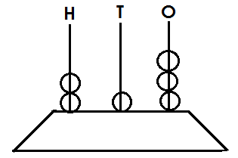=

- What time is shown below?
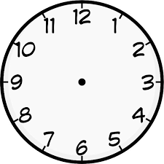
- The cost of a cake is sh. 300. Find the cost of two cakes.

- Take away;
4 9
- 2 9

- What number is shown below?

- What fraction is shaded?

- Write in figures.
Two hundred seventeen

- Ahebwa has 61 goats. His mother has 38 goats. How many goats do they have altogether?

- What is the last month of the year?

SECTION B
- Arrange these numbers starting from the biggest to the smallest.
- I48, 98, 132, 177

- 15, 21, 12, 24, 18, 17

- Name the shapes shown below.
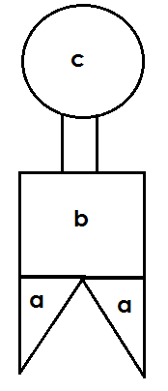
a ____________________
b _____________________
c ______________________
- Match correctly.
7 days 1 year
60 minutes 1 hour
12 months 1 week
24 hours 1 day
- Complete the multiplication table.
X | 2 | 3 | 4
1 | 2 | _____ | _____
2 | _____ | _____ | 8

- Work out correctly.
- 4 2
- 6

- Jane had 63 bottles. 25 bottles broke. How many remained?

- Anna is 9 years old. Tim is 14 years older.
- Who is older?

- Find their total age.

- Take away Anna’s age from Tim’s age.

- (a) Which fraction is bigger?
or

(b) Subtract;
-

(c) Which fraction is shaded and unshaded?
shaded =
unshaded =

- (a) sixteen plus = twenty
(b) Mother had 20 oranges. She shared them equally among 5 children. How many did each get?

(c) Group these in two.
=
- Six pupils collected apples as shown.

Lule Asea Akech Agaba Kato Nabirye
Names of pupils

- How many apples did Akech collect?

- Who collested 2 apples?

- How many apples did Kato collect?

- Who did not collect any apples?

- How many apples did Lule collect?

